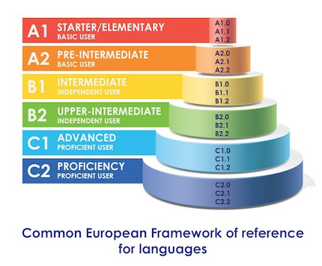

CEFR level | A1 | A2 | B1 | B2 | C1 | C2
Vocabulary | 500 | 1,000 | 2,000 | 3,000 | 4,000 | 5,000
Hours of study | 50 | 200 | 400 | 600 | 800 | 1,000

